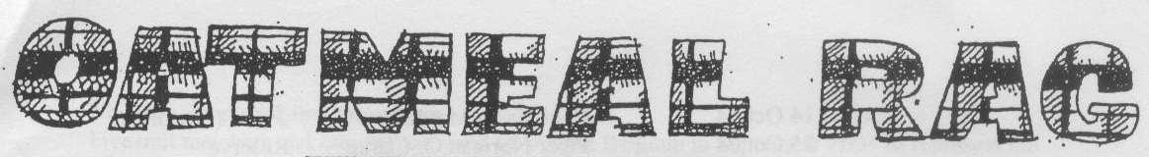
THE QUEEN’S OWN CAMERON HIGHLANDERS OF CANADA
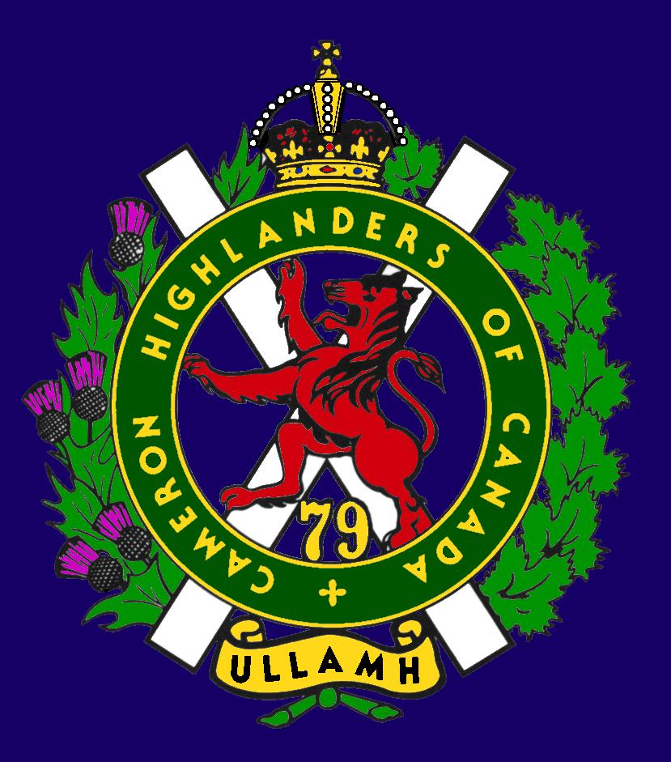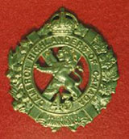
CAMERON ASSOCIATION IN CANADA
THE QUEEN’S OWN CAMERON HIGHLANDERS OF CANADA
MINTO ARMOURY, 969 ST. MATTHEWS AVE
WPG, MB R3G 0J7

2010/2011 OFFICERS

PRESIDENT | Taffy Gray | 198 Seekings St  Headingly, MB | R4J 1B1 | 889-5655
VICE-PRES | Steve MacMillan | 351 Ainslie St  Wpg, MB  sdmacmillan@shaw.ca | R3J 2Z7 | 831-0542
SECRETARY | Hugh O’Donnell | 713 Cambridge St  Wpg, MB  hodonnell@shaw.ca | R3M 3G2 | 285-7222
TREASURER | Dave Gibson | 104 William Gibson Bay  Wpg, MB  dwgibson@mts.net | R3C 5L7 | 222-9509

Executive Board

Past Pres | Bill Worden | 47 Flett Ave | R2K 3N3 | 669 -9888
 | Frederick Carsted | 91 Redview Dr | R2N 3C3 | 254-7533
 | Marc Gautron | 312-15 Arden Ave. | R2M 2J8 | 296-7656
 | Len Johnson | 1094 Bat Rd | R1A 3L1 | 757 - 2023
 | Mitch Prudhomme | 790 Parkhill St | R2Y 0V5 | 837-5778
 | Karen Tyler | 255 Aldine St  Wpg, MB | R3J 2A9 | 414-0973
Foundation Trustees | Don Steenson  (2010 – 2012) | Dave Gibson  (2009 – 2011)
Auditor | Tom Russell | 376 Oak St | R3M 3R5 | 488-0088

* Last Post *
RODERICK (ROD) DAVID MCMILLIN (published on July 09, 2011)
http://www.passagesmb.com/obituary_details.cfm?ObitID=180186

RODERICK DAVID MCMILLIN 1925 - 2011 On July 3, 2011 Roderick David McMillin passed away at Deer Lodge Centre after a lengthy illness. He is survived by his wife of 64 years, Dorothy, daughter Linda Sparrow, son-law Norman Sparrow, and the pride of Dad's life, grandson Scott Sparrow. Dad was born in Winnipeg on November 21, 1925. Dad fought in the Second World War in Holland. He carried the ghosts of that time to the grave with him. Dad retired from the C.N.R. many years ago and then he and Mom started to travel, taking many trips to Austria and Germany and in later years to Victoria. His most memorable trip was back to Holland for the 60th reunion of the liberation. He was able to reconnect with a family that he met in the war but had lost all contact with. Mom and Dad became fast friends with them and visited back and forth. Mom and Dad moved into supportive housing at Riverwood Square in March of 2010 and I would like to thank the staff there for all their care and compassion to Dad while he was there and to Mom during this very difficult time. I would also like to thank the Homecare staff who saw to Dad's needs in Riverwood Square. Dad was always very proud of his relationship with the Queens Own Cameron Highlanders and to that end flowers are gratefully declined and a donation to the Cameron Highlanders Foundation would be appreciated. They can be reached at Queen's Own Cameron Highlanders Foundation Minto Armouries, 969 St. Matthews St., Winnipeg, MB, R3G 0J7. He will be missed NEIL BARDAL FUNERAL CENTRE (204) 949-2200 nbardal.mb.ca

MICHAEL LEON OBSNIUK (published on April 16, 2011)
http://www.passagesmb.com/obituary_details.cfm?ObitID=177214

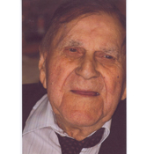

MICHAEL LEON OBSNIUK November 10, 1918 - April 16, 2011 Peacefully with family by his side, our Dad passed away at the Lakeshore General Hospital in Ashern, MB. He was 92 years old. Dad served in Queens Own Cameron Highlanders of Canada overseas where he met and married our Mother in 1946. They were married for 49 years until her passing in 1995. After the war, he did numerous jobs until he became employed with the CNR as a truck driver until his retirement. In lieu of flowers, a donation to a charity of your choice would be appreciated. A family memorial will be held on May 29, 2011 at the Arnason Funeral Home in Ashern, MB. Arrangements by: ARNASON FUNERAL HOME Ashern Lundar 1-204-768-2072 1-866-323-3593

HOWARD WALTER REICHERT (published on May 07, 2011)
http://www.passagesmb.com/obituary_details.cfm?ObitID=178024
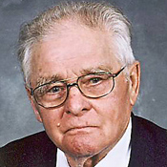

HOWARD WALTER REICHERT 1921 - 2011 On Thursday, May 5, 2011 at the Boundary Trails Health Centre, Sergeant Howard W. Reichert MM, aged 90 years, of Morden, MB beloved husband of Isabel (nee Rosen) Reichert. Besides his wife, he leaves to mourn his passing three daughters: Margaret Maggie and Colin Obee, Kent, England, Connie and Seann Blohmm, Thornhill District, MB, and Janice Slater and Tony Snihur, Morden, MB. Cremation has taken place. A memorial service was held on Friday, May 13 at 2:00 p.m. at Wiebe Funeral Chapel, Morden, with ash inurnment to take place at the Chapel Columbarium prior to the service. In lieu of flowers, if friends so desire, donations may be made to Boundary Trails Health Centre, Palliative Care or a charity of one's choice. Wiebe Funeral Chapel, Morden, MB in care of arrangements, 204-325-4201 www.wiebefuneralhomes.com

Edwin John Strachan
http://obits.dignitymemorial.com/dignity-memorial/obituary.aspx?n=Edwin-Strachan&lc=3808&pid=150632533&mid=4653279

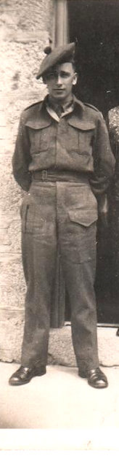
Edwin John Strachan passed away on April 27, 2011 at Kelowna, BC at the age of 85 years. He will be remembered by his loving wife of 60 years Marie; daughter Penny (Leroy) Stein; sons Leslie (Shirley), and David (Anne); and many grandchildren, nieces and nephews.
Edwin enlisted with the Canadian Forces in Winnipeg in 1944, at the age of 18. He served in WWII with the Queen's Own Cameron Highlanders of Canada, and was wounded during the liberation of Holland. He spent one year with the occupation forces, with the Royal Winnipeg Rifles.
After the war, Ed followed his family to Kelowna, and went to work with J.W. Hughes on the farm/orchard. After a few years, he moved on to Sun-Rype as a shipper/receiver, where he remained for 35 years. His free time was very 'family centred'; he loved camping and the outdoors, and was a great sports fan – especially when it came to his children and grandchildren. He was a goal judge for over 25 years – officiating for the Packers and the Buckeroos.
A private family service was held. Memorial donations in Ed's name may be made to the Kelowna Hospital Foundation, 2268 Pandosy Street, Kelowna, BC V1Y 1T2.
Arrangements under the direction of First Memorial Funeral Services, Kelowna, BC.
* Sick & Visiting *
Ed Abraham WW2 Cameron had a stroke near Easter. Ms. Leona Stilling tells me that he's recovering OK but is currently paralyzed on his right side. His vital signs are good and he is able to speak, eat regular meals, and is working very hard to regain mobility.

Doug Ludlow (Post WW2 Cameron) Is still in the St Norbert Personal Care Home at 50 St Pierre St. Any and all visitors are advised strongly to call ahead before visiting. The number to call is 269 – 4538.
http://members.winnipegdirect.info/p/st-norbert-personal-winnipeg-50-st-pierre/

Lloyd McDougall (39/45 – and still ticking !) 19 Sept 2010
Tanya Bowen (formerly a clerk with 38 CBG) still does us the very great service of dropping in to Deer Lodge to visit with Lloyd and bring him the latest Oatmeal Rag.
For those who can drop by he’s Lloyd McDougall and he’s in Tower 5 or
T5 – 531, DEER LODGE CENTER, 2109 PORTAGE AVE.

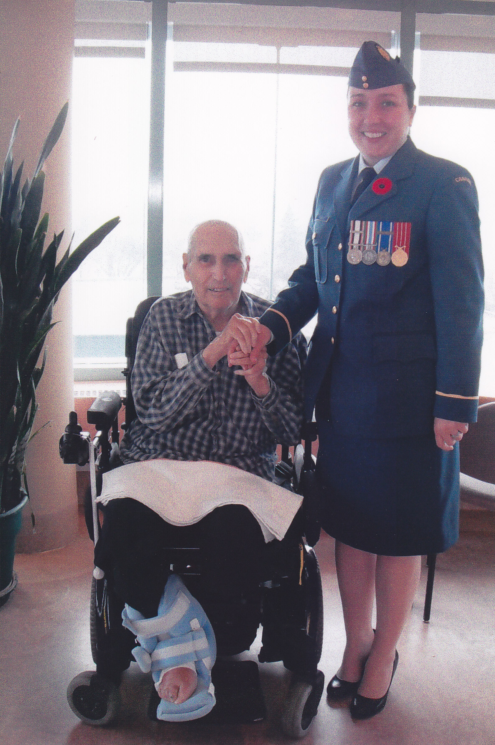

Roy Taylor (WW2 RAF, Post WW2 Cameron) Roy is at home and comfortable. He enjoys short visits and does get tired quickly.

* President's Message *

Here's hoping this note finds everyone in good health. It's amazing how fast the summer has gone. What with the flooding and now all the hot weather, there has certainly been an awful lot to deal with. Our hearts go out to those that are battling the floods and we all wish the farming community the best in these trying times.
It's nice to have out troops coming home from Afghanistan and we'll always remember the ones who made the ultimate sacrifice.
I would like to thank everyone who has supported me during my run as the president - it has been quite a busy term.
The next event coming up will be the Annual Cameron Reunion and Golf Tournament. It would be nice to see as many of you there as possible.
I was very pleased to represent the Association by presenting the Cameron Association Highland Dance Trophy to the overall winner Ms. Stacie Nixon. Well done Stacie !
My big regret was that I was unable to get out to the Cameron Highland Games but Hugh had my back. Hopefully next year !
In closing I would like to remind everyone that your help with prizes, cash, or whatever for the Cameron Golf to please contact Bill Worden or Don MacDonald with the details.

Ullamh !
Taffy

* Vice-President's Message *
Steve’s last few weeks with the Army were during the flood. He hopes that everybody’s back is feeling much better now.

* Reconnect with Former Camerons *

This is an important thing to do for the health of the Association. There are still lots of former Camerons out there that we don’t know about for various reasons. Just because you or they weren’t WW 2 or Korea veterans doesn’t make them any less important to the Cameron Association.
Please help us locate them and bring them back into the fold. The ranks of the WW 2 guys are terribly thin now and the torch must pass to the following generations of Camerons that we may continue to serve our fellow Camerons.

Greg Graham, Lloyd Thomas, and Andy Debruin are all hoping to make it out to the Reunion this year. How about you?

Our favourite combat plumber, Shaun Delamere was in town for the Air Force Run on 29 May 2011. He says hi to all but didn’t have much time for more than coffee and crossing the starting line. He did the plumber trade proud by actually finishing the race.

From: Capt David Duggins
Sent: Friday, May 27, 2011 12:52 PM
Subject: Re: Cameron newsletter link for you sir.
Thanks for keeping me in the loop. Please keep me on your list!
DD

From: brent jones <brentsjones@hotmail.com>
To: <hodonnell@draega.net>
Date: Thu, 28 Apr 2011 21:28:19 -0600
Subject: Private Stanley George Jones
Hello,
I have recently discovered that my great uncle gave his life in the second world war. He served with the Queen's Own Cameron Highlanders of Canada and I was hoping you might be able to provide a bit more information about where and how he lost his life. Here is what I know so far:
Private Stanley George Jones
Service #: A/102820 Age:31 Force: Army
Unit: Queen's Own Cameron Highlanders of Canada
Died: Oct 5, 1944
From what I understand he died in a hospital in France and was laid to rest in the Netherlands.
My father also served in the Canadian Armed Forces, and as I grow older I have taken interest in Canadian military history. I am especially interested in World War II. I would like to be able to tell my children and future generations a bit more about Stanley, the battle he fought in, and the sacrifice he made. Any information you might have would be greatly appreciated.
Regards,
Brent
* Dues Payable Now *

It is almost membership renewal season and thanks in advance to those of you who plan to pay up at the August 19-20th 2011 Reunion. For any others out there please send your payment to our membership/treasurer Dave Gibson ASAP.

* Cameron Association Constitution Amendment Motion *
The date of our next AGM will be determined at the Cameron Reunion and announced that night. Your input is welcome but we do need to work around the Unit training plan.

Introduction
The current Cameron Constitution is a very good one but I feel that we have inadvertently missed offering some category of membership to some very important people who belong to our Regimental Family.
The Honorary Membership category which enjoys voting rights and the right to serve on the Executive is in my opinion rightly capped at 20%. This is intended to limit the impact of well meaning people who have never served in the Regiment and may not understand some of the factors which are of vital importance to those who have seen such service.

Our numbers are very likely to shrink over time and the 20% cap may limit us to only a few new such Honorary Members every 5 years or so. It may also completely exclude widows, sons, and daughters of former Regular Members who wish to stay in touch and/or help to promote interest in the Regiment and Cameron Association.

To correct this unintentional oversight I propose that we amend the current Cameron Constitution of 15 Jan 2011 at our 2011 AGM as proposed below.

The current Paragraph 5 reads:

5. The Association may admit to Honorary Membership in The Association any person of good character who is not eligible as a Regular member as herein provided but who is in sympathy with the aim and objects of The Association and who would assist in the advancement of same. Honorary Membership within The Association shall be limited to twenty percent (20%) of the total membership of The Association. Each application for Honorary Membership shall be considered by the Executive Board as to its worthiness for acceptance or rejection.

I respectfully recommend that we amend our 15 Jan 2011 Constitution by creating a new membership category paragraph to read:

The Association may admit to Associate Membership in the Association any person of good character who is not eligible as a Regular Member as herein provided but who is in sympathy with the aim and objects of The Association and who would assist in the advancement of same. The Associate Membership category is non-voting and Associate Members cannot hold office, but are encouraged to support Association functions. Its intent is to allow families of past or current serving members of the Regiment and former Cameron Cadets of adult age to become members of The Association. The annual subscription fee will be the same that of Regular and Honorary membership categories with discretion allowed for special cases by the Association Executive.

I further recommend that if the new membership category is created that we renumber the existing paragraphs starting with Paragraph 6 and onwards sequentially.

Hugh O’Donnell

* Unit Flood Fight 2011 *

Some of our guys were employed with “A” Coy of the 38 CBG Domestic Response Companies during the spring 2011 flood fight. I have been told by RSM Boyd that the Domestic Response Company from 38 CBG working in the Cartier, St. Francis Xavier, Headingly area did an excellent job. Thanks from all to P/M Ferguson, Cpls Toews, Curry, and all of the others that I didn’t catch the names of.
http://www.flickr.com/photos/lfwapao/5714273127/lightbox/

* Unit Flood Fight 1950 *

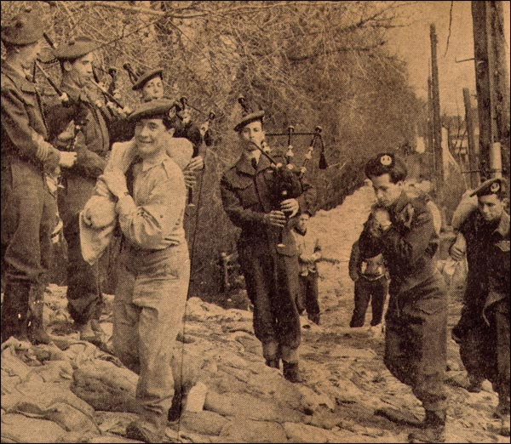

Camerons being piped to work on Winnipeg dike during 1950 Flood
www.manitobaphotos.com

* Unit Web Site *
The Unit web site is still up running at:
http://thequeensowncameronhighlandersofcanada.net/
You will also find quite a few pictures from the 100th on the Picasaweb page at:
http://picasaweb.google.com/camsofc
Also of interest is this month’s featured web site link: http://dutyandvalour.com/

* Regimental Events *
Reinforcements: Rumours abound that one or two are out there. If not some one had best get to work.

Rounds Completed:
Cameron Highland Games Weekend: 25- 26 June 2011. The plans from the Trenchard Brothers worked out very well indeed ! Special thanks are due to HLCol Bob Vandewater for his assistance with providing quality refreshments, and WO Bruce Breustedt and his family who hosted the event again. Of course a quick thanks to all of the members of the regiment, their families and children who attended the event. Cpl Bill Gomm from Army News was also there to capture the spirit of the event.
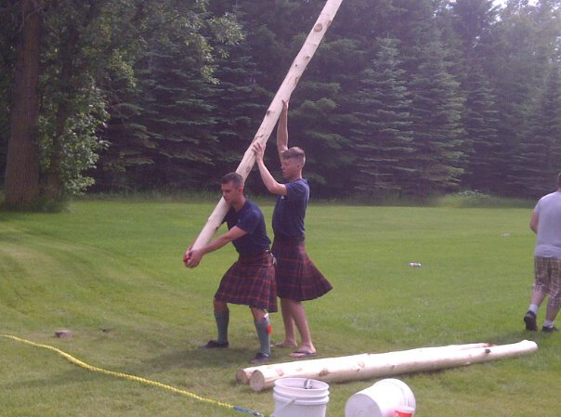

Scotch Tasting Night: Another great night was had. See WO Lumsden for next year’s tickets, but not quite yet please !

Incoming Rounds:
Annual ReunionWeekend: 19 - 20 August 2011
Friday: Minto Armouries 1900 – 2345 hrs
Saturday Golf & Dinner: Assiniboine Golf Club no later than 1330 hrs as usual.
Register with Mr. Donald MacDonald for the golf & BBQ long before Friday pm if you can - please !
Spouses and children are welcome at the BBQ – but you’re the one who makes the call about their being able to golf !
The BBQ steak dinner will start at about 1700 hrs.

Donald MacDonald
(204) 771-3825
dmacdona@mymts.net
Golf & BBQ = $40
BBQ Only = $25
* Links *

Aaron Greyling is the founder of a Canadian military history encyclopedia (wiki) called "Duty & Valour".
http://dutyandvalour.com/

“A” Company, The Highlanders, 4th Battalion, The Royal Regiment of Scotland in action!
http://snafu-solomon.blogspot.com/2011/07/company-highlanders-4th-battalion-royal.html?m=1

Afghanistan photo essays:
http://www.boston.com/bigpicture/2011/06/afghanistan_may_2011.html

Dogs of War pictorial #13 Cdn K9 private co.
http://totallycoolpix.com/2011/05/dogs-of-war/

Memorials in France – this one is in Fontenay le Marmion where Maj McManus & WO2 Arbour held on so grimly “B” Coy during OP TOTALIZE, 08 Aug 1944. Watch for more about WO2 Arbour in our next Oatmeal Rag:

http://www.normandie44lamemoire.com/versionanglaise/fichesvillesus/fontmarlaizus2.html

This is another interesting site with loads of CF and other NATO Allies:
http://lest-we-forget.zxq.net/

* Historical Notes *
The following two items are by the kind permission of their authors and the demand of the Association membership. Gentlemen, we thank you.

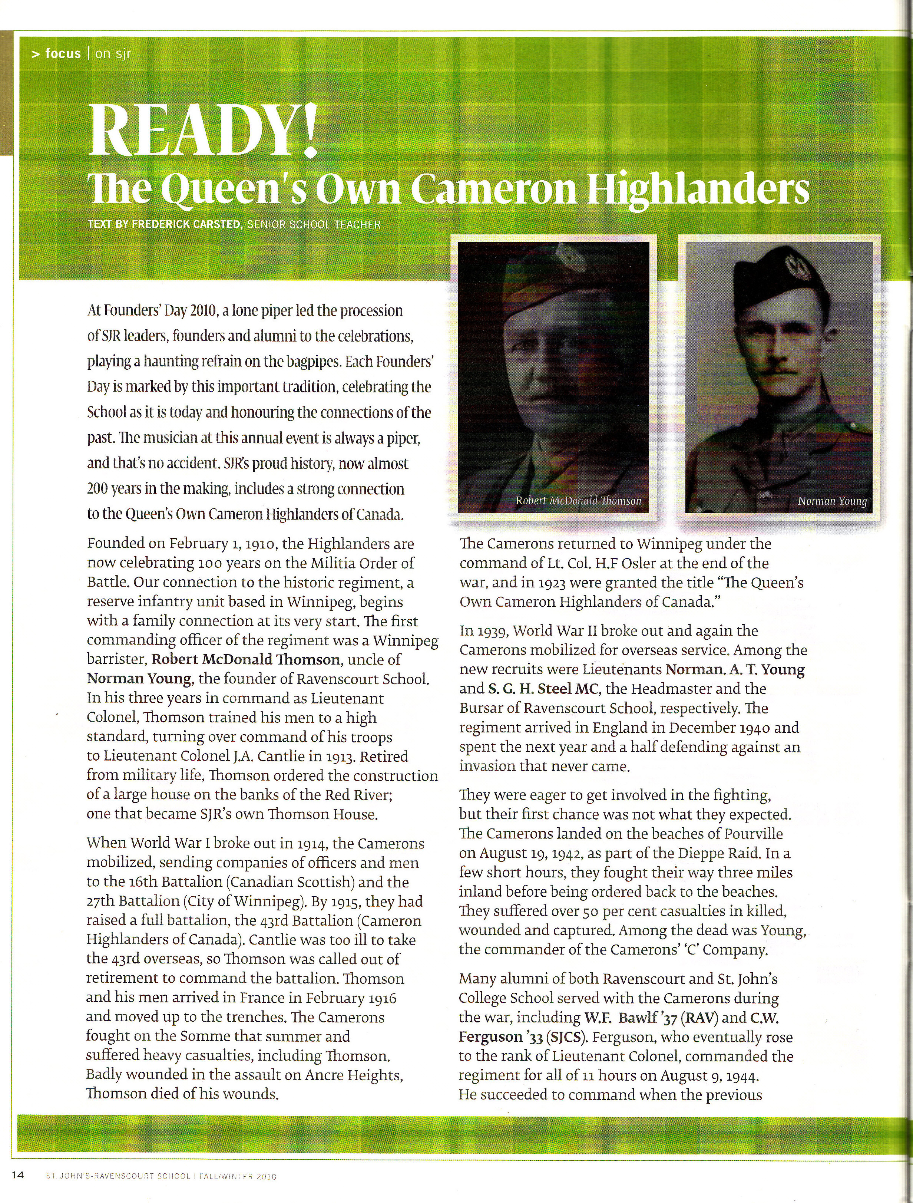
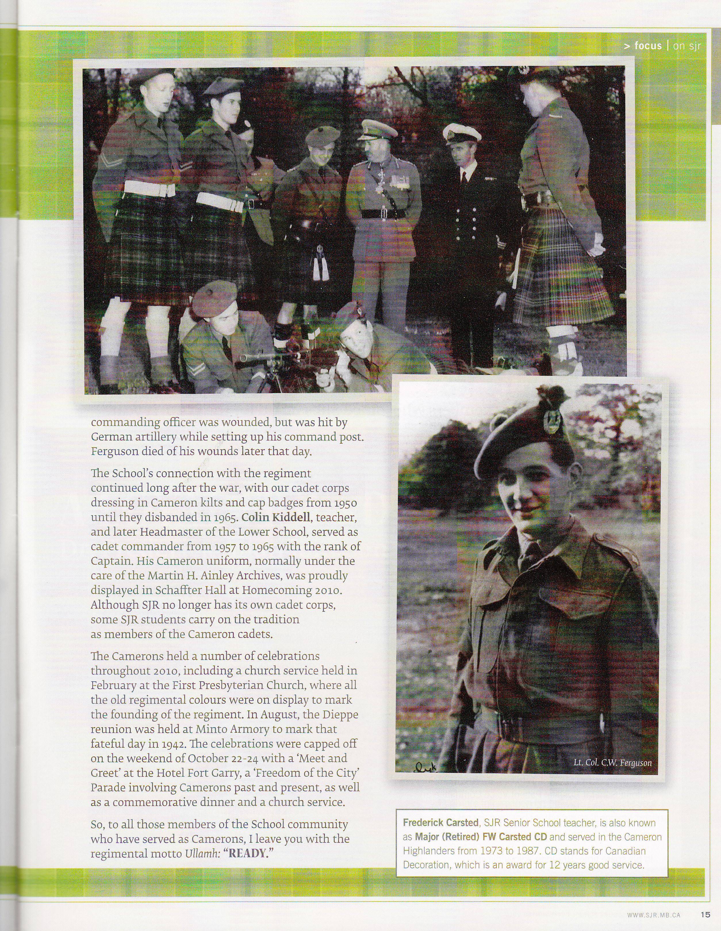
CENTENARY SERMON/ADDRESS
By
The Honourable Reverend
William Alexander Blaikie, PC, MLA, BA, MDiv

100th anniversary reflection
The Queen’s Own Cameron Highlanders of Canada
First Presbyterian Church, Winnipeg, MB
The Hon. Rev. Bill Blaikie
In preparation for my remarks this morning I did some reading about the history of Scottish regiments. As I begin my anniversary reflection today I am reminded of what I read about the regiment known as the Cameronians, not the Camerons but the Cameronians. Also known as the Scottish Rifles, it was a regiment which primarily recruited in Lanarkshire and the Glasgow area. My grandfather, Robert Blaikie, served in it before coming to Canada in 1911. The Cameronians no longer exist. In 1968 they chose to disband rather than amalgamate. The origin of the Cameronians is religious. Cameronian was the name given to the most militant of the Presbyterian sects. The first muster of the regiment took place in 1689, and it was the custom of the regiment to place sentinels at church parades and the sermon did not commence until an officer notified the minister with a shout of “All clear”.
Conscious of the fact that we live in a quite different time, and of the fact that I didn’t intend to say anything provocative, I took the liberty of not having sentinels posted this morning, or waiting for the all clear.
The Camerons of Winnipeg are associated with the Camerons of Scotland, a regiment first raised in 1793 by Allan Cameron of Erracht, whose tartan, Cameron of Erracht, the Camerons of Winnipeg wear to this day. It was a tartan designed by Allan Cameron’s mother, Mrs. Marjory Cameron, and was unique among the old regimental tartans in that it was not derived from or a variant of the Government or Black Watch Tartan. For this reason it was jealously guarded, as was the very existence of the regiment. Twice it was rumoured to be slated for disbanding.
On one occasion Queen Victoria herself stepped in to save the day. They eventually were amalgamated, in 1961, with the Seaforth to form the Queen’s Own Highlanders, a regiment which itself does not exist anymore, although the pipes and drums of the successor regiment still wear the Cameron tartan.
All this is by way of saying that our first feeling this morning should be one of gratitude. Gratitude for the continuing existence of the QOCH of Canada, our beloved regiment, for 100 years of service to country and community, and for the prospect of continuing for many years to come. Ever since 1967, when the unification of the Canadian Armed Forces took place, there has been anxiety about the future of highland regiments in the Canadian Army.
I was in the Pipes and Drums when the regiment performed a Trooping of the Colour for Canada’s centennial in 1967, and feelings were running high then. Indeed, we were inspected that day by then Defense Minister Paul Hellyer, who had initiated unification. Over 30 years later Paul Hellyer had formed his own political party, the Canadian Action Party, and came to see me in my Parliamentary office in Ottawa to make a political proposal that I rejected, but that is another story.
The Camerons have endured, and highland regiments have endured, because notwithstanding their Scottish origins, highland regiments are as Canadian as maple syrup. They are part of our history, our present, and our future.
Our Old Testament reading this morning was from Deuteronomy 32. The passage was one in which the faithful are instructed to “remember the days of old, think of the generations long ago, ask your father to recount it, and your elders to tell you the tale”.
The Camerons have fewer and fewer elders to tell us the story of World War II, and of course none to tell us the story of World War I. But there are other stories to tell, of service in peacetime, of service in peacekeeping, of volunteers in Bosnia, and Afghanistan. And fortunately their stories have been gathered over the years, in different anniversaries, in books that provide a cherished and interesting record of the Cameron experience and contributions. The most recent, of course, is the book Ladies from Hell, put together by Murray Burt.
I consider myself lucky to have known many of the World War II vets, and to have worked with some of them on projects important to them. I am thinking here in particular of Harry Long, of the Dieppe Veterans, who was persistent in his pursuit of better recognition of those who were there that fateful day on August 19th, 1942. It eventually resulted in my bringing forth a private members’ bill that after some negotiation led to the creation of a Dieppe ribbon that could be worn with existing medals. Just recently we lost two other World War II Canadian vets that I will always have fond memories of, Jim Vick, who was a drummer in the Camerons when I played in the band, and Sergeant Ray Shotbolt, who passed away just a week ago. Ray was a constituent of mine for decades, and always had a word of encouragement for me.
Perhaps it’s because I play the pipes myself, but for me the outstanding image in my mind whenever I think of the regiment in an emotional way is the vision of Alex Graham piping on the front of the landing craft as the Camerons landed on the beach at Pourville, near Dieppe. If you ever have the opportunity to visit Pourville, you will get a very vivid impression of just how vulnerable they were as they came in on that beach.
In 1992 I was part of the Canadian delegation to Dieppe on the 50th anniversary of the raid, and saw it for myself. I was also grateful to the Minister of National Defense at the time, Gerry Merrithew of New Brunswick, for allowing me the honour of playing the lament at the cemetery in Dieppe. On a lighter note, I must say that I have a somewhat different memory of Pipe Major Graham in the National Guard barracks in Detroit Lakes when he could not find his spats as we were getting ready to go on parade. He was not a happy camper or Cameron.
Remember the days of old. What I want to do briefly then is go way back, further back than the Camerons, to the story of Andrew the fisherman on the sea of Galilee who became a disciple of Jesus, and who was eventually crucified himself, as was Jesus, for preaching that Caesar, the emperor, was not Lord. Jesus was Lord, and the goal of life was to seek the Kingdom of God and its justice, and not justice as it was understood by the ruling elite.
Legend has it that Andrew was crucified on a diagonal cross because he did not think himself worthy of being crucified on the same kind of cross as Jesus. That diagonal cross is what came to be known as the St. Andrew’s Cross, and is the cross found on the badge of the Cameron Highlanders, as well as the Scots Guards, whose prayer starts with “Almighty God, whose blessed Son did say unto St. Andrew, ‘Follow me’, grant that we who wear the cross of thy Holy Apostle may follow thy Son with impunity; be made stronger in brotherhood, and fierce against all enemies of our Saviour”.
In the Gospel of John, Andrew, who had been a disciple of John the Baptist, was the first disciple, the first man to be called a disciple, the first to answer the call. And it is important to note that the call goes out to, and is answered by, ordinary folk, in this case fishermen who were working with their nets by the shore. It was a call that, legend has it, would take Andrew all the way to Russia, and later to Greece, where he was put to death at a place called Patrae. Scots share St. Andrew as patron saint with Ukraine. Legend also has it that his bones were removed to Amalfi, Italy, in 1208, but that before this took place, a person in charge of relics at Patrae was visited by an angel who ordered him to take three finger bones, an arm bone, and a knee cap of Andrew, and take them to the westernmost limits of the then known world. So it was that St. Andrew became the patron saint of Scotland.
In his history of the St. Andrew’s Society of Winnipeg, Tom Sanders suggests that there are others who believe that the real reason St. Andrew became the patron saint of Scotland was because it was Andrew who suggested to Jesus, after the feeding of the 5000 with a few fishes and loaves, that they ought to get some baskets to pick up what was left over, to make sure nothing was wasted.
May the Queen’s Own Cameron Highlanders of Winnipeg always be, like St. Andrew, the first to answer the call, both individually and collectively. Not the call to war, or the call to fight, or the call to kill, but the call when necessary to put themselves in harm’s way for the greater good of their community, this country, and the world.
It’s not always easy to discern what those who wait for the call should be called to do. There hasn’t been a military action in the history of Canada that hasn’t been accompanied by some kind of debate, and that is appropriate. Not all decisions are the right decisions, no matter how high up the ladder they are made. But the Gospel reading this morning is clear. “Greater love hath no man than this, that he lay down his life for his friends”. It is a form of such love that has motivated generations of Camerons to answer the call, and it is their answer over the years, that we give thanks for, and celebrate this day. As the song reminds us:
There’s many a man of the Cameron clan
Who has followed his chief to the field
He has sworn to support him or die by his side,
For a Cameron never can yield.
I hear the pibroch sounding, sounding,
Over the mountains and glens
While light spring my footsteps are trampling the heath
Tis the March of the Cameron Men
Tis the March, tis the March,
Tis the March of the Cameron Men.

I need a piper for a Cameron Association member’s funeral ? ? ?
For those of you who are trying to plan ahead or suddenly need to book a piper for one of our Comrades and don’t know how it is done here you go:
1. Contact the President of the Cameron Association or the Editor of the Oatmeal Rag at a reasonable hour; and
2. We’ll pass you the contact information of the current Cameron Pipe-Major (because the appointment does actually change from century to century or so and otherwise you may call the wrong guy); and
3. The PM will help you to make the appropriate arrangements.

Cheers for now,

Art Sutton & Hugh O’Donnell



